Date and time | Channel | Copy | Image | Notes
14 Sept | Facebook | Do you know a young person who is learning to drive? Help them to be safe on the roads with our #Top3RoadSafetyTips | 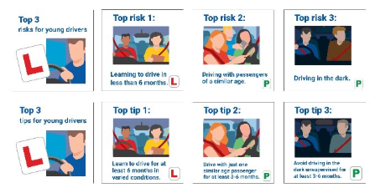
16 Sept | Instagram / TikTok | Passing your driving test is just the beginning.  Driving in different weather, heavy traffic, and at night takes time and experience. Give yourself at least six months to build confidence and develop safe habits that will last a lifetime.  #Top3Risks #DriveSafe | 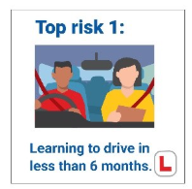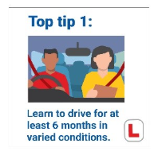
20 Sept | Facebook | Young drivers face 3 big risks on the road:  - Lack of experience  - Driving late at night  - Passenger distractions  More information on our website: LINK TO PRESS RELEASE | 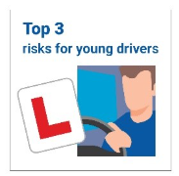
22 Sept | Instagram / TikTok | Your licence is new. Your experience is too.  Having friends in the car is more fun but also increases risk of collision.  Limit passengers in the first months after passing your test. It could save lives.  More information on our website: LINK TO PRESS RELEASE  #Top3Risks #RoadSafety | 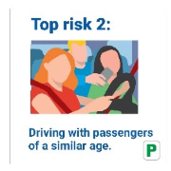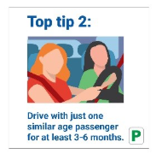
27 Sept | Instagram / TikTok | Just passed your test?  Night driving brings new challenges, from reduced visibility to fatigue. Avoid driving in the dark unsupervised for the first 3 to 6 months to build your experience gradually.  More information on our website: LINK TO PRESS RELEASE | 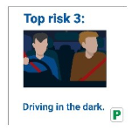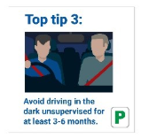
29 Sept | Facebook | The Top 3 risks facing young drivers for young drivers are preventable by:  - Learning for over 6 months.  - Avoiding driving 11pm–6am.  - Limit young passengers.  Talk about it. Make a plan. Drive safe.  More information on our website: LINK TO PRESS RELEASE  #Top3Risks #DriveSafe | 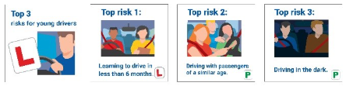
1 Oct | Instagram / TikTok | In 2022, almost 1 in 5 driver fatalities were aged 17–24. The Top 3 campaign is here to change that.  More information on our website: LINK TO PRESS RELEASE  #Top3Risks #SaferDriving | 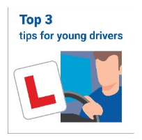
4 Oct | Facebook | Do you know a young person who is learning to drive? Help them to be safe on the roads with our #Top3RoadSafetyTips  More information on our website: LINK TO PRESS RELEASE

